# Smart Farmer - IOT Enabled Smart Farming Application

**Project Development Phase**

# Sprint Delivery -2

|  |  |
| --- | --- |
| **Team ID** | PNT2022TMID20067 |
| **Project Name** | Smart Farmer-IOT Enabled Smart Farming Application |

**Software:**

1. **Create device in the iot watson platform:**

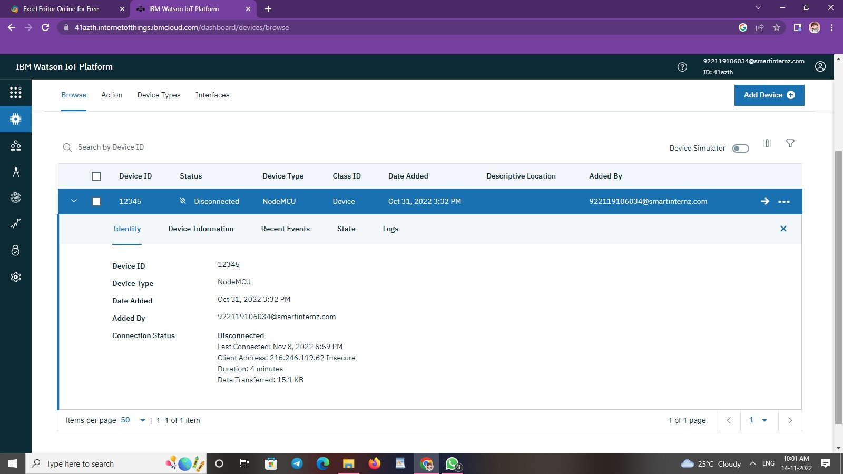

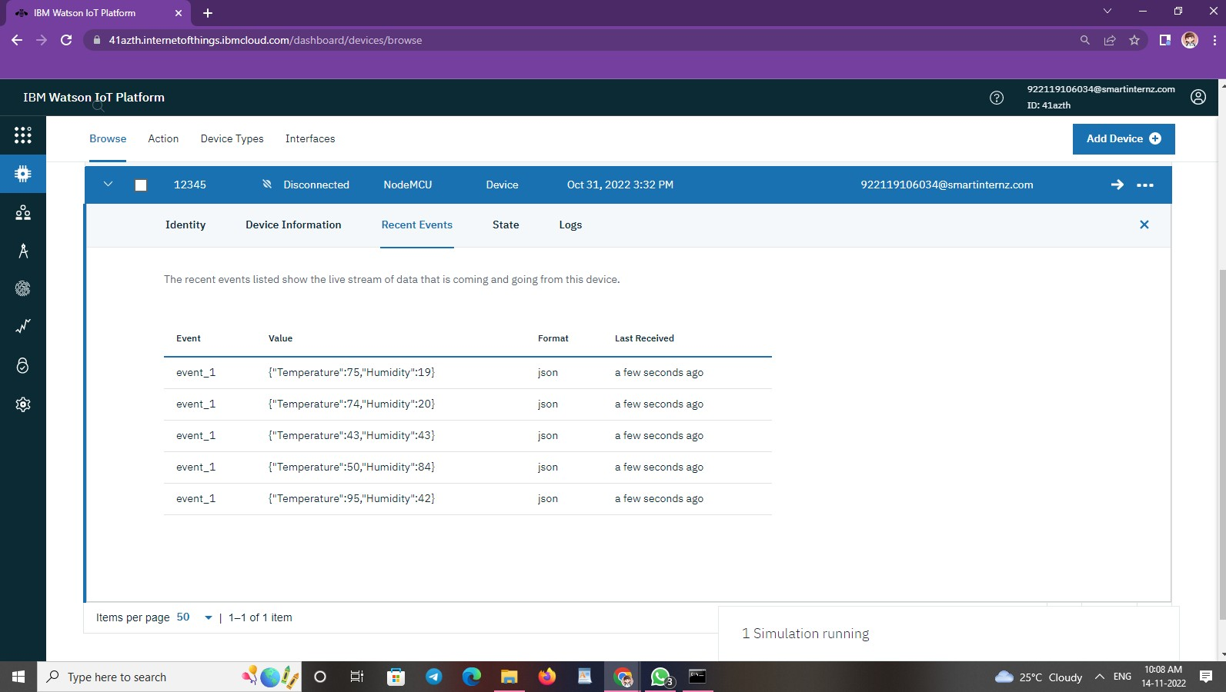

1. **Workflow for iot scenarios using local node red:**

